Reading 2.5: Networking on AWS
WHAT IS NETWORKING?
Networking is how you connect computers around the world and allow them to communicate with one another. In this trail, you’ve already seen a few examples of networking. One is the AWS global infrastructure. AWS has created a network of resources using data centers, Availability Zones, and Regions.
KNOW THE NETWORKING BASICS
Think about sending a letter. When sending a letter, there are three pieces of information you need.
- The payload or letter inside the envelope.
- The address of the sender in the From section.
- The address of the recipient in the To section.
Let’s go further. Each address must contain information such as:
- Name of sender and recipient
- Street
- City
- State or province
- Zip, area, or postal code
- Country
You need all parts of an address to ensure that your letter gets to its destination. Without the correct address, postal workers are not able to properly deliver the message. In the digital world, computers handle the delivery of messages in a similar way. This is called routing.
WHAT ARE IP ADDRESSES?
In order to properly route your messages to a location, you need an address. Just like each home has a mail address, each computer has an IP address. However, instead of using the combination of street, city, state, zip code, and country, the IP address uses a combination of bits, 0s and 1s.
Here is an example of a 32-bit address in binary format:
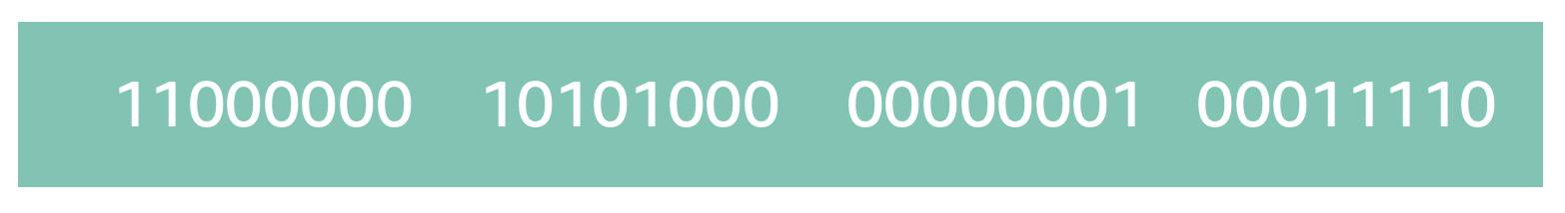
It’s called 32-bit because you have 32 digits. Feel free to count!
WHAT IS IPV4 NOTATION?
Typically, you don’t see an IP address in this binary format. Instead, it’s converted into decimal format and noted as an Ipv4 address.
In the diagram below, the 32 bits are grouped into groups of 8 bits, also called octets. Each of these groups is converted into decimal format separated by a period.
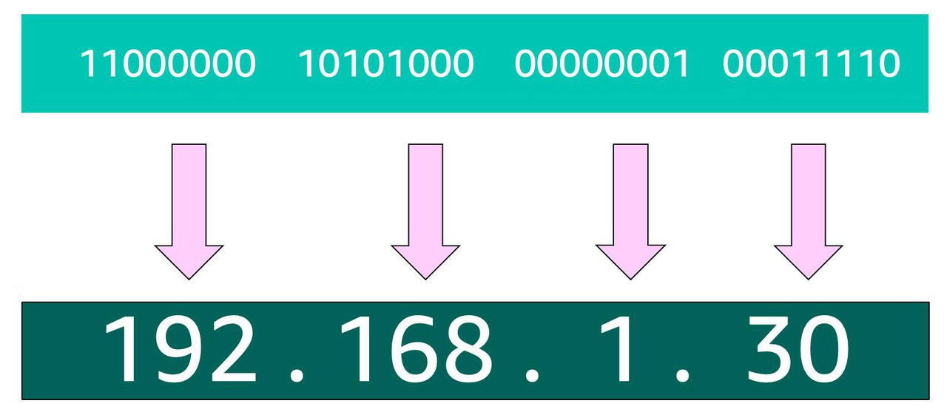
In the end, this is what is called an Ipv4 address. This is important to know when trying to communicate to a single computer. But remember, you’re working with a network. This is where CIDR Notation comes in.
USE CIDR NOTATION
192.168.1.30 is a single IP address. If you wanted to express IP addresses between the range of 192.168.1.0 and 192.168.1.255, how can you do that?
One way is by using Classless Inter-Domain Routing (CIDR) notation. CIDR notation is a compressed way of specifying a range of IP addresses. Specifying a range determines how many IP addresses are available to you.
CIDR notation looks like this:

It begins with a starting IP address and is separated by a forward slash (the “/” character) followed by a number. The number at the end specifies how many of the bits of the IP address are fixed. In this example, the first 24 bits of the IP address are fixed. The rest are flexible.
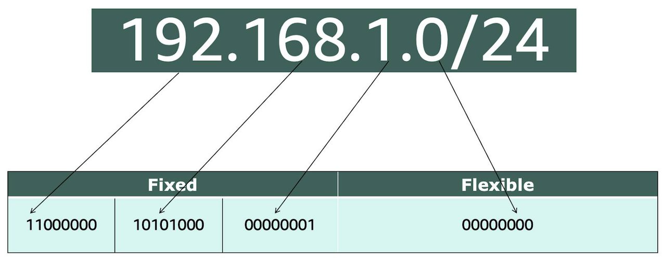
32 total bits subtracted by 24 fixed bits leaves 8 flexible bits. Each of these flexible bits can be either 0 or 1, because they are binary. That means you have two choices for each of the 8 bits, providing 256 IP addresses in that IP range.
The higher the number after the /, the smaller the number of IP addresses in your network. For example, a range of 192.168.1.0/24 is smaller than 192.168.1.0/16.
When working with networks in the AWS Cloud, you choose your network size by using CIDR notation. In AWS, the smallest IP range you can have is /28, which provides you 16 IP addresses. The largest IP range you can have is a /16, which provides you with 65,536 IP addresses.

Reading 2.6: Introduction to Amazon VPC
A VPC is an isolated network you create in the AWS cloud, similar to a traditional network in a data center. When you create a VPC, you need to choose three main things.
- The name of your VPC.
- A Region for your VPC to live in. Each VPC spans multiple Availability Zones within the Region you choose.
- A IP range for your VPC in CIDR notation. This determines the size of your network. Each VPC can have up to four /16 IP ranges.
Using this information, AWS will provision a network and IP addresses for that network.
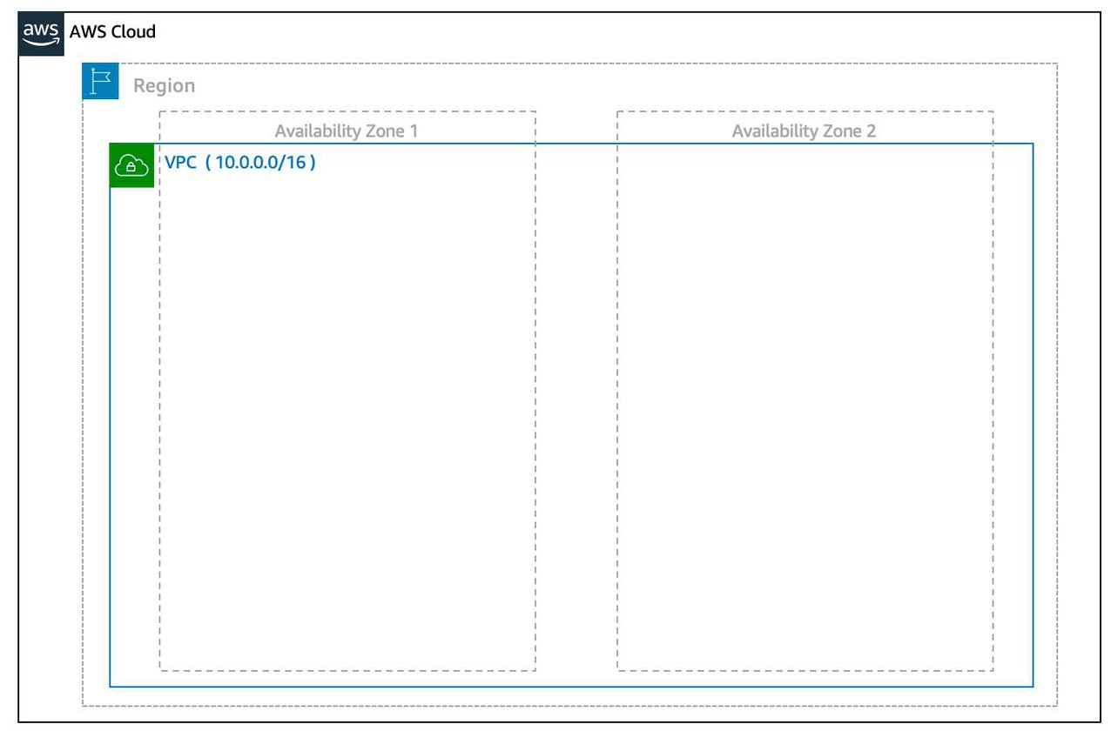
Create a Subnet After you create your VPC, you need to create subnets inside of this network. Think of subnets as smaller networks inside your base network—or virtual area networks (VLANs) in a traditional, on-premises network. In an on-premises network, the typical use case for subnets is to isolate or optimize network traffic. In AWS, subnets are used for high availability and providing different connectivity options for your resources. When you create a subnet, you need to choose three settings.
- The VPC you want your subnet to live in, in this case VPC (10.0.0.0/16).
- The Availability Zone you want your subnet to live in, in this case AZ1.
- A CIDR block for your subnet, which must be a subset of the VPC CIDR block, in this case 10.0.0.0/24.
When you launch an EC2 instance, you launch it inside a subnet, which will be located inside the Availability Zone you choose.
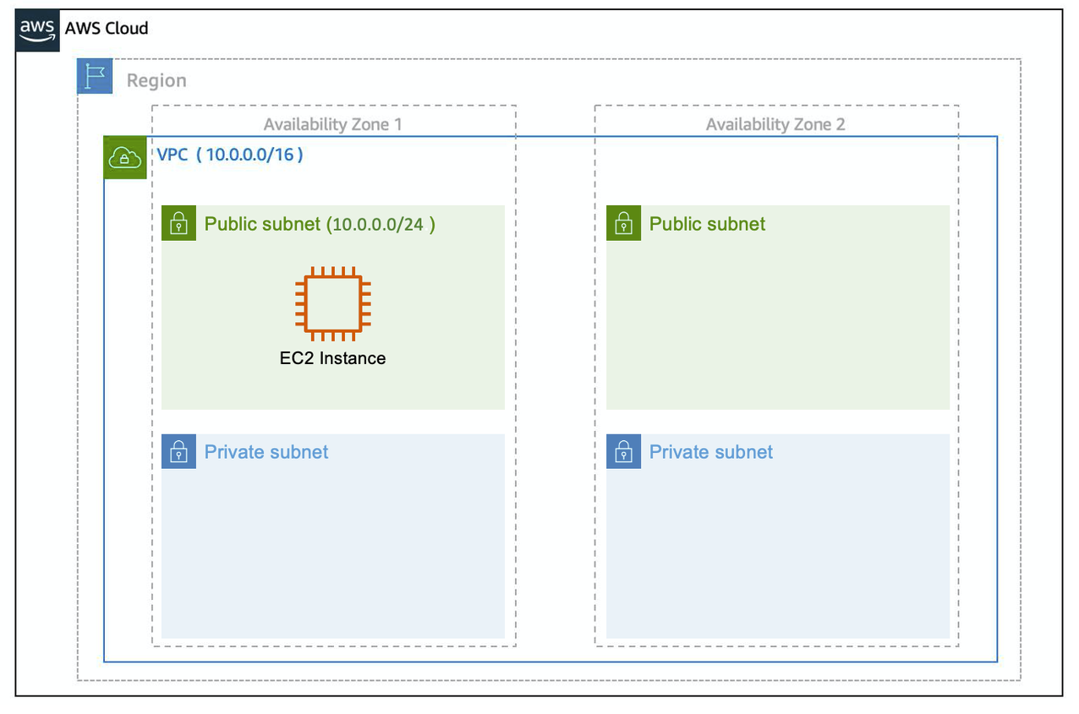
High Availability with A VPC When you create your subnets, keep high availability in mind. In order to maintain redundancy and fault tolerance, create at least two subnets configured in two different Availability Zones.
As you learned earlier in the trail, it’s important to consider that “everything fails all the time.” In this case, if one of these AZs fail, you still have your resources in another AZ available as backup.
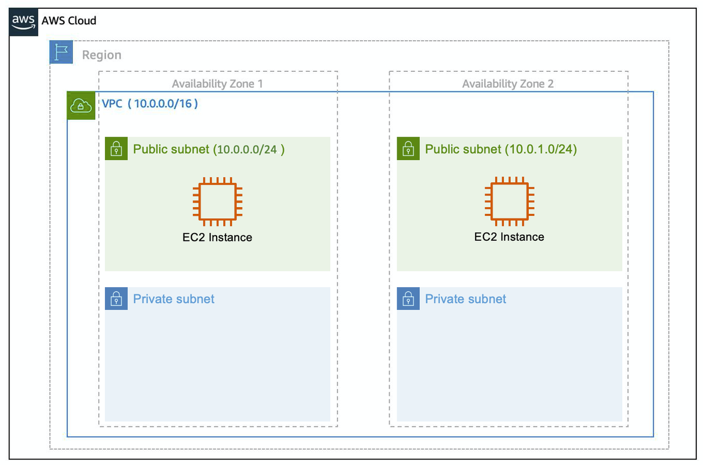
Reserved IPs For AWS to configure your VPC appropriately, AWS reserves five IP addresses in each subnet. These IP addresses are used for routing, Domain Name System (DNS), and network management.
For example, consider a VPC with the IP range 10.0.0.0/22. The VPC includes 1,024 total IP addresses. This is divided into four equal-sized subnets, each with a /24 IP range with 256 IP addresses. Out of each of those IP ranges, there are only 251 IP addresses that can be used because AWS reserves five.
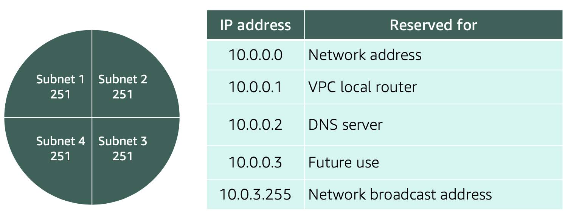
Since AWS reserves these five IP addresses, it can impact how you design your network. A common starting place for those who are new to the cloud is to create a VPC with a IP range of /16 and create subnets with a IP range of /24. This provides a large amount of IP addresses to work with at both the VPC and subnet level.

Gateways
Internet Gateway
To enable internet connectivity for your VPC, you need to create an internet gateway. Think of this gateway as similar to a modem. Just as a modem connects your computer to the internet, the internet gateway connects your VPC to the internet. Unlike your modem at home, which sometimes goes down or offline, an internet gateway is highly available and scalable. After you create an internet gateway, you then need to attach it to your VPC.
Virtual Private Gateway
A virtual private gateway allows you to connect your AWS VPC to another private network. Once you create and attach a VGW to a VPC, the gateway acts as anchor on the AWS side of the connection. On the other side of the connection, you’ll need to connect a customer gateway to the other private network. A customer gateway device is a physical device or software application on your side of the connection. Once you have both gateways, you can then establish an encrypted VPN connection between the two sides.
Resources:
- External Site: AWS: VPC with public and private subnets (NAT)
- External Site: AWS: custom route tables
- External Site: Customer Gateway
- External Site: AWS: What Is Amazon VPC?
- External Site: AWS: VPCs and subnets
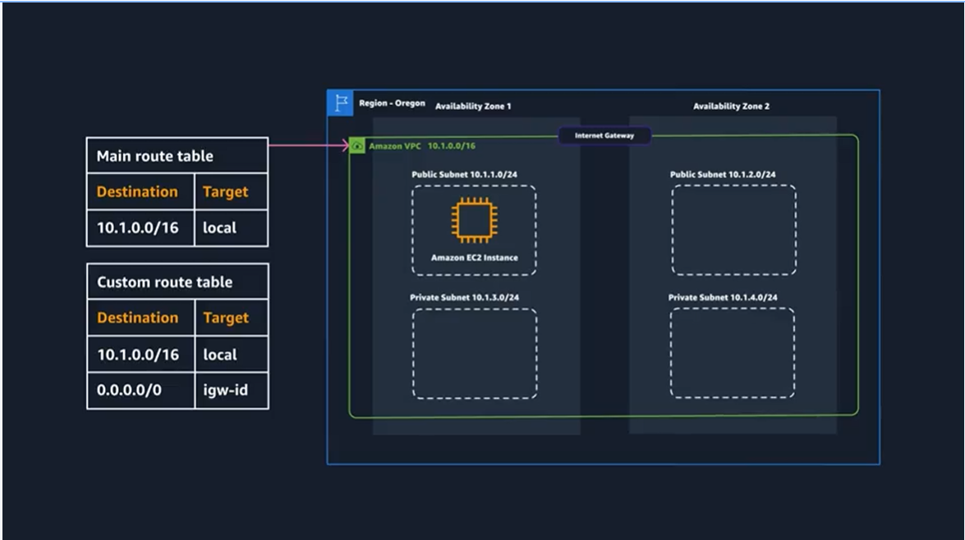
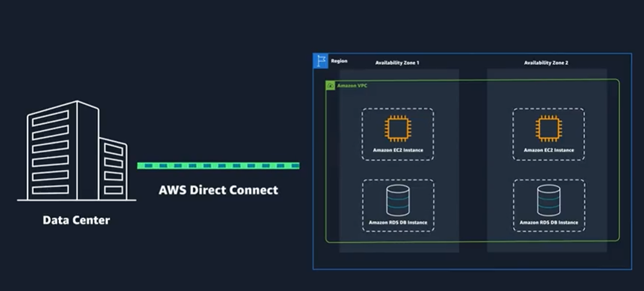

Reading 2.7: Amazon VPC Routing and Security

The Main Route Table
When you create a VPC, AWS creates a route table called the main route table. A route table contains a set of rules, called routes, that are used to determine where network traffic is directed. AWS assumes that when you create a new VPC with subnets, you want traffic to flow between them. Therefore, the default configuration of the main route table is to allow traffic between all subnets in the local network. Below is an example of a main route table:
There are two main parts to this route table.
- The destination, which is a range of IP addresses where you want your traffic to go. In the example of sending a letter, you need a destination to route the letter to the appropriate place. The same is true for routing traffic. In this case, the destination is the IP range of our VPC network.
- The target, which is the connection through which to send the traffic. In this case, the traffic is routed through the local VPC network.

Custom Route Tables
While the main route table controls the routing for your VPC, you may want to be more granular about how you route your traffic for specific subnets. For example, your application may consist of a frontend and a database. You can create separate subnets for these resources and provide different routes for each of them.
If you associate a custom route table with a subnet, the subnet will use it instead of the main route table. By default, each custom route table you create will have the local route already inside it, allowing communication to flow between all resources and subnets inside the VPC.
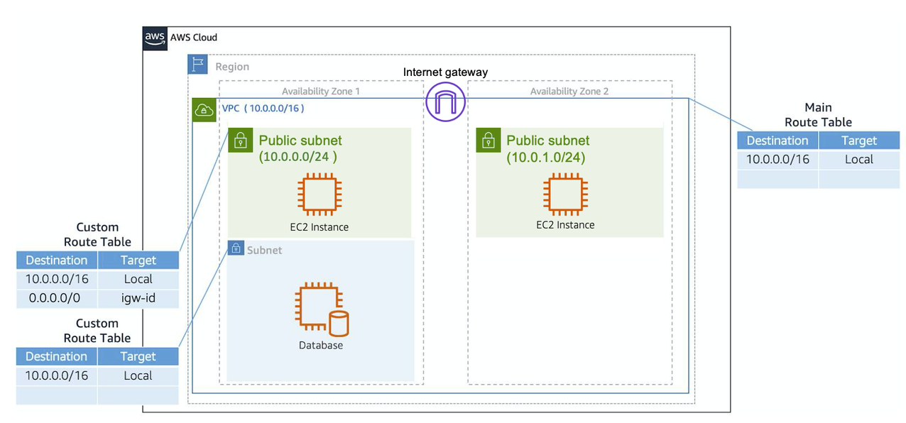

Secure Your Subnets with Network ACLs
Think of a network ACL as a firewall at the subnet level. A network ACL enables you to control what kind of traffic is allowed to enter or leave your subnet. You can configure this by setting up rules that define what you want to filter. Here’s an example.
Inbound
Rule # | Type | Protocol | Port Range | Source | Allow/Deny
100 | All IPv4 traffic | All | All | 0.0.0.0/0 | ALLOW
* | All IPv4 traffic | All | All | 0.0.0.0/0 | DENY
Outbound
Rule # | Type | Protocol | Port Range | Source | Allow/Deny
100 | All IPv4 traffic | All | All | 0.0.0.0/0 | ALLOW
* | All IPv4 traffic | All | All | 0.0.0.0/0 | DENY
The default network ACL, shown in the table above, allows all traffic in and out of your subnet. To allow data to flow freely to your subnet, this is a good starting place. However, you may want to restrict data at the subnet level. For example, if you have a web application, you might restrict your network to allow HTTPS traffic and remote desktop protocol (RDP) traffic to your web servers.
Inbound
Rule # | Source IP | Protocol | Port | Allow/Deny | Comments
100 | All IPv4 traffic | TCP | 443 | ALLOW | Allows inbound HTTPS traffic from anywhere
130 | 192.0.2.0/24 | TCP | 3389 | ALLOW | Allows inbound RDP traffic to the web servers from your home network’s public IP address range (over the internet gateway)
* | All IPv4 traffic | All | All | DENY | Denies all inbound traffic not already handled by a preceding rule (not modifiable)
Outbound
Rule # | Destination IP | Protocol | Port | Allow/Deny | Comments
120 | 0.0.0.0/0 | TCP | 1025-65535 | ALLOW | Allows outbound responses to clients on the internet (serving people visiting the web servers in the subnet)
* | 0.0.0.0/0 | All | All | DENY | Denies all outbound traffic not already handled by a preceding rule (not modifiable)
Notice that in the network ACL example above, you allow inbound 443 and outbound range 1025-65535. That’s because HTTP uses port 443 to initiate a connection and will respond to an ephemeral port. Network ACL’s are considered stateless, so you need to include both the inbound and outbound ports used for the protocol. If you don’t include the outbound range, your server would respond but the traffic would never leave the subnet.
Since network ACLs are configured by default to allow incoming and outgoing traffic, you don’t need to change their initial settings unless you need additional security layers.

Secure Your EC2 Instances with Security Groups
The next layer of security is for your EC2 Instances. Here, you can create a firewall called a security group. The default configuration of a security group blocks all inbound traffic and allows all outbound traffic.
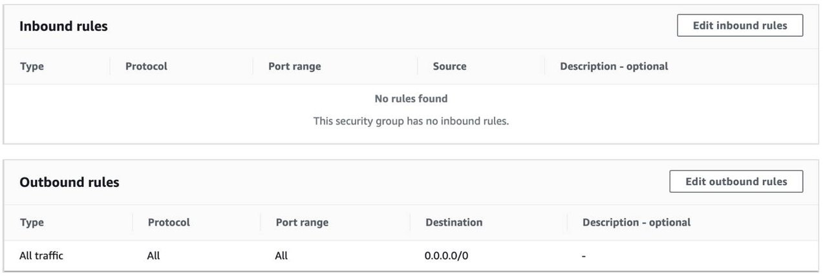
You might be wondering: “Wouldn’t this block all EC2 instances from receiving the response of any customer requests?” Well, security groups are stateful, meaning they will remember if a connection is originally initiated by the EC2 instance or from the outside and temporarily allow traffic to respond without having to modify the inbound rules.
If you want your EC2 instance to accept traffic from the internet, you’ll need to open up inbound ports. If you have a web server, you may need to accept HTTP and HTTPS requests to allow that type of traffic in through your security group. You can create an inbound rule that will allow port 80 (HTTP) and port 443 (HTTPS) as shown below.
Inbound rules
Type | Protocol | Port Range | Source
HTTP (80) | TCP (6) | 80 | 0.0.0.0/0
HTTP (80) | TCP (6) | 80 | ::/0
HTTPS (443) | TCP (6) | 443 | 0.0.0.0/0
HTTPS (443) | TCP (6) | 443 | ::/0
You learned in a previous unit that subnets can be used to segregate traffic between computers in your network. Security groups can be used to do the same thing. A common design pattern is organizing your resources into different groups and creating security groups for each to control network communication between them.
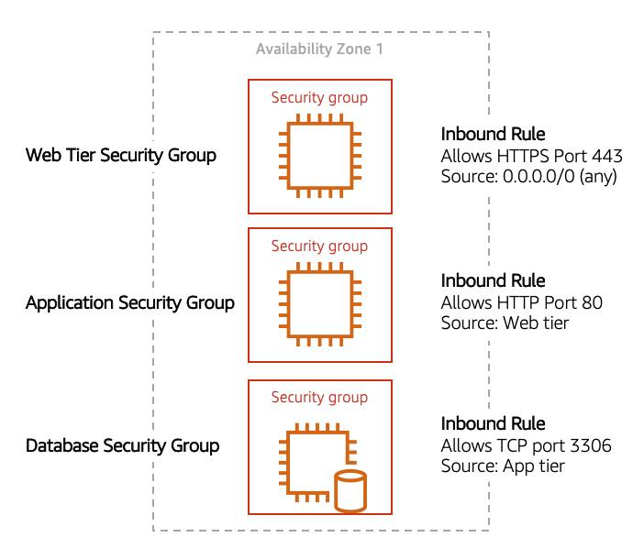
This example allows you to define three tiers and isolate each tier with the security group rules you define. In this case, you only allow internet traffic to the web tier over HTTPS, Web Tier to Application Tier over HTTP, and Application tier to Database tier over MySQL. This is different from traditional on-premises environments, in which you isolate groups of resources via VLAN configuration. In AWS, security groups allow you to achieve the same isolation without tying it to your network.
Resources:
- External Site: AWS: Route tables
- External Site: AWS: Example routing options
- External Site: AWS: Working with routing tables
- External Site: AWS: Network ACLs
- External Site: AWS: Security groups for your VPC
- External Site: AWS: I host a website on an EC2 instance. How do I allow my users to connect on HTTP (80) or HTTPS (443)?

Common network troubleshooting steps for Amazon VPC
In the demos throughout this course, you will see the Employee Directory Application being launched onto a Amazon EC2 instance that is placed in a public subnet in an Amazon VPC. There are multiple networking configurations that play into whether an instance is accessible to the internet or not.
Below we will run down a list of configurations you should check if you ever have a public EC2 instance with a web application that is not loading as expected.
1. Internet gateway
Ensure that an Internet Gateway (IGW) is attached to your VPC. Without the internet gateway, no traffic will be allowed in or out of the VPC.
2. Route tables
Check the route table associated with the subnet of your EC2 instance. Ensure there is a route with a destination of 0.0.0.0/0 that points to the Internet Gateway. This route allows outbound traffic to the internet.
3. Security groups
Review the security group settings attached to your EC2 instance. Make sure there are inbound rules allowing HTTP (port 80) and/or HTTPS (port 443) traffic from the internet (0.0.0.0/0). Also, verify that outbound rules allow traffic to leave the instance.
4. Network Access Control Lists
Check the NACLs associated with your subnet. Ensure that they allow inbound and outbound traffic for HTTP and HTTPS. Unlike security groups, NACLs are stateless, so you must explicitly allow both inbound and outbound rules.
5. Public IP address
Ensure your EC2 instance has a public IP address assigned. You can check this in the EC2 console under the instance details. If it does not have a public IP, relaunch the instance and ensure you have the configuration for assigning a public IP address set correctly.
6. HTTP vs HTTPS
Confirm that your application is accessible via the correct protocol. If your application is configured for HTTPS, ensure SSL/TLS certificates are correctly installed and configured. Also, check if the web browser is trying to connect via the wrong protocol (HTTP instead of HTTPS or vice versa). For this course, the application is operating via HTTP, double check that your browser is not trying to connect via HTTPS. You can do this by selecting the address bar in the browser and making sure the address starts with http and not https.
7. User data script
If your instance uses a user data script to configure the application on launch, verify that the script has run successfully. Check the instance logs (/var/log/cloud-init.log or /var/log/cloud-init-output.log) for any errors that may have occurred during the execution of the user data script.
8. Permissions
Verify the permissions and roles attached to your EC2 instance. Ensure the instance has the necessary IAM roles and policies to access any required AWS services, such as S3, DynamoDB, or RDS.
9. Personal network permissions
Ensure that your personal or corporate network does not have restrictions blocking access to the public IP address of your EC2 instance. Some networks might have firewalls or proxy settings that could block outbound traffic to certain IP ranges or ports.
10. Application
Ensure that your application code is correctly deployed and running. Check the application's logs to diagnose any runtime errors. Also, make sure the web server (e.g., Apache, Nginx) is installed and running.

Q# | Correct Answer | Key Logic
1 | The AWS Region that the VPC will reside in. | A VPC is a regional service. While you create subnets in specific Availability Zones later, the VPC itself is tied to a Region.
2 | Subnets | You use route tables to tell the traffic within a Subnet where to go (e.g., to the internet or to other subnets).
3 | B and C | To go "public," a VPC needs an Internet Gateway (IGW) AND a Route Table entry pointing 0.0.0.0/0 to that IGW.
4 | The CaaS model offers computing resources... on demand, by using virtual services. | CaaS (like EC2) provides the virtual hardware so you don't have to manage physical servers.
5 | Blocks all inbound traffic and allows all outbound traffic by default. | Security Groups are "Stateful" and follow the Principle of Least Privilege: nothing gets in unless you specifically allow it.
6 | Instance family and instance size | In t3.medium, t3 is the family (burstable) and medium is the size (CPU/RAM).
7 | With AWS Fargate, AWS manages and provisions the underlying infrastructure... | Fargate is "Serverless" for containers—you don't manage the underlying EC2 instances; AWS does.
8 | Users do not pay for idle resources. | This is the "Pay-as-you-go" hallmark of serverless. If your code isn't running, your bill is $0.
9 | False | Lambda has limits (e.g., a 15-minute timeout). Long-running or heavy processing tasks are often better suited for EC2.
10 | Virtual machines (VMs) | EC2 is the primary service for traditional virtual servers in the AWS cloud.
11 | When an instance is in a running stage | AWS typically doesn't charge for "Pending" or "Stopped" instances (though you still pay for the attached storage/EBS).
12 | c5 | c stands for Compute-optimized, and 5 indicates the 5th generation of that hardware.
13 | Docker | Docker is the industry-standard runtime for building and running containers on virtual machines.
14 | An upload of a file to the Amazon S3 source bucket | This is a classic "Event-Driven" architecture example where S3 triggers Lambda to process a file.
15 | True | That is the definition of Serverless: the "server" still exists, but AWS handles all the management, patching, and scaling.
16 | False | Some "Global" or "SaaS" style services (like S3 or IAM) do not require you to configure a VPC.
17 | Classless Inter-Domain Routing (CIDR) notation | CIDR (e.g., 10.0.0.0/16) defines the IP range and total number of available addresses in your network.
18 | ...network ACLs allow incoming and outgoing traffic... security groups block all inbound traffic and allow all outbound traffic. | NACLs (Subnet level) are broad and stateless; Security Groups (Instance level) are specific and stateful.

https://aws.amazon.com/what-is/cidr/
https://cidr.xyz/
https://www.davidc.net/sites/default/subnets/subnets.html
https://googlecloudplatform.github.io/gke-ip-address-management/

